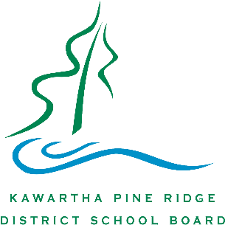
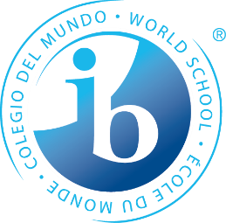
The IB Programme FAQ’s

What is the IB Programme?
- IB stands for International Baccalaureate, a challenging academic program for students in grade 11 and 12.
- The IB Programme at Kenner offers a specialized enriched curriculum unique in Peterborough which is internationally-minded and interdisciplinary.
- The IB is a KPR Board-supported programme and students are guaranteed busing if they live within Peterborough County.
What does an IB Diploma consist of?
- The IB philosophy promotes academic roundedness. As such, there are IB courses in 6 subject areas: English, French, Humanities, Sciences, Mathematics and Arts.
- Students take a critical thinking course called the Theory of Knowledge which addresses the question “How do you know what you know?”
- The IB features an enhanced community leadership component called Creativity Action and Service (CAS) of approximately 150 hours.
- With support from specially-trained faculty, students write a mini-thesis of 4000 words called the Extended Essay in a subject matter of the students own design.
Describe the Pre-IB Programme?
- Students gradually become familiar with the skills and challenges of IB by being exposed to these during grades 9 and 10.
- Students are streamed in their IB prep subjects and enjoy electives as well.
- Students are surrounded by like-minded peers who love learning and inspire each other.
- Students who complete the pre-IB program have two extra years in enriched classrooms which serves as a foundation for their entire secondary experience.
Mark These Dates
IB Open House “Be IB for a Day”
Thursday, November 16th Thursday, December 7th
Hear what IB is all about Spend a day in the unique IB Programme
6:00 pm -- 8:00 pm in Kenner library 9:00 am – 3:00 pm at Kenner (Lunch provided)
705-743-2181 x 259 705-743-2181 x 259 to RSVP

The IB Programme FAQ’s

What Courses are available in IB?
- The IB Programme at Kenner offers internationally-respected, advanced University preparation in the following subjects: English Literature, French, World History, Geography, Biology, Chemistry, Physics, Mathematics, and Visual Art. NEW: Dance and Film Studies joined in 2016!!
What are the advantages of IB?
- Preferred program placement in many universities.
- Transfer credits exempt students from first-year courses: valued at $1500-$2000 apiece.
- Advanced consideration for scholarships and bursaries.
- Lifelong skills in thinking, critical analysis, writing, speaking and community leadership.
- Global competency in a highly competitive international economy.
How does IB French Compare to Immersion?
- Favourably. IB Graduates develop advanced skills in French, both oral and written, along with a rich understanding of the French diaspora. Kenner IB French students consistently score well above the world IB average, with competitive results on independent measures such as DELF.
How does IB compare to AP?
- IB is superior. With its interdisciplinary focus, subjects are not taught in isolation. Students emerge with a more complex understanding of their disciplines, and how disciplines interact.
Can students with IEP’s apply to the IB Programme? What about ELL students?
- Yes. All accommodations in a student’s IEP are respected in the IB Programme at Kenner.
- Yes. The IB Programme includes students who speak 19 languages other than English and French; language accommodations are available for these students to thrive in IB.
How do I apply?
- You need a copy of your recent report card, a letter of reference from a current teacher, a sample of a piece of writing and samples of a recent Unit test in Math and Science.
- Go to our website, or call Peter Mullins, our IB Coordinator, at 705-743-2181 x 259 for an application. Deadline for applications is Friday, January 26th 2018.
To find out more, contact: Peter Mullins, IB Programme Coordinator
705-743-2181 x 259, peter_mullins@kprdsb.ca

