WHAT IS THE IB DIPLOMA PROGRAMME?
IB stands for International Baccalaureate. IB is a highly regarded, exciting and challenging two-year (grade 11 & 12) university preparation program.
lB emphasizes international mindedness, and top-notch training in all courses. IB students achieve high standards in critical thinking, advanced lab work, oral communication, and written language.
As part of a global community of scholars, Kenner IB graduates are recognized world-wide, and they thrive in university.
WHAT IS THE PRE-IB PROGRAMME?
Students accepted into IB in grade 9 enter the Pre-IB Programme. They are streamed with like-minded students into prep courses in English, Math, Science, French and Humanities. As a result, students develop skills and confidence necessary for success in the IB Diploma Programme. Pre-IB students select from a wide range of electives to complete their timetable.
FIND OUT MORE:

“IB OPEN HOUSE”
Thursday, November 16, 2017
Kenner Collegiate Vocational Institute 6:00 pm
in the Eldon P Ray Auditorium
“Be IB for a Day”
Thursday, December 7, 2017
Tour the school, meet current students,
and experience what is unique about IB.
9:00 am-3:00 pm. Lunch provided.
WHAT OTHER STUDENTS ASK ABOUT THE IB PROGRAMME
Will I have time for other activities and a social life?
Most students find that they do have time. IB students are engaged in school and are leaders in the community. Kenner is a smaller school, so it is easy to get involved in sports and clubs, and to connect with other students with similar interests. These varied activities help you to develop a wide circle of friends.
Is there a lot of homework?
Sometimes, but most students find IB homework both interesting and challenging. High school usually involves more homework than elementary school, whatever program you choose.
What are the advantages of IB?
IB graduates are highly sought after by universities around the world. They are granted transfer credits, enjoy preferential program placement and have increased access to scholarships. IB graduates are lifelong learners, and are skilled thinkers, writers, researchers and communicators. They solve problems confidently and are conscientious global citizens.
For more information, an application to IB,
or to arrange "Be IB for a Day" contact:
Peter Mullins
IB Programme Coordinator
Kenner Collegiate Vocational Institute and Intermediate School
633 Monaghan Rd South
Peterborough. ON K9J 5J2
(705) 743-2181 x259
Email: peter_mullins@kprdsb.ca
or visit http://kenner.kprdsb.ca or www.ibo.org
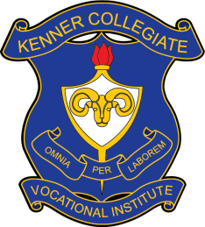
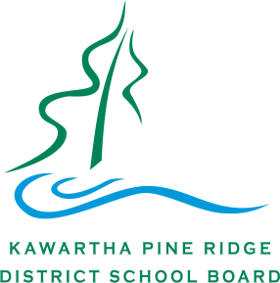
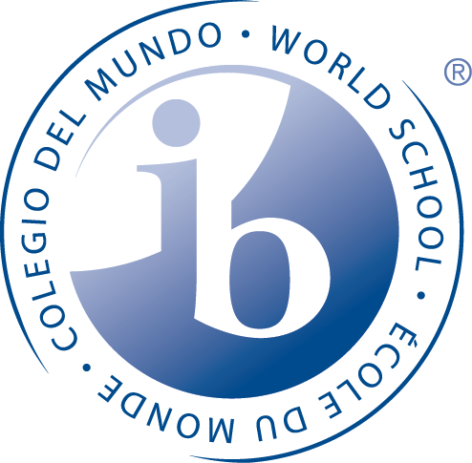
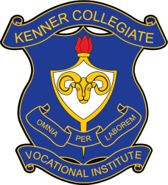
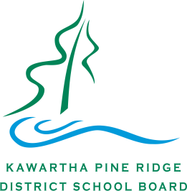
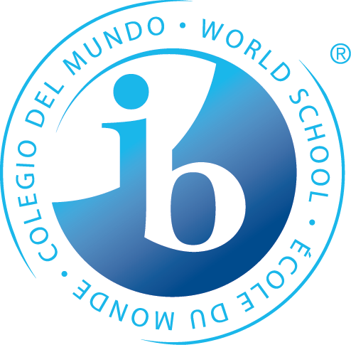
INTERNATIONAL BACCALAUREATE
Diploma Programme
Challenge Yourself
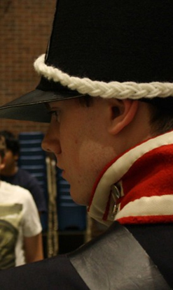
ARE YOU CURIOUS?
Do you want to know how the world really works?
Do you care about the future of our planet?
Do you want to get involved in global issues?
Do you want to feel confident in your skills and prepared for your future?
THE KENNER ADVANTAGE
Supportive – Kenner's smaller size allows for increased individual attention for students, and results in retention rates well above the international IB average.
Established – In May 2018, IB at Kenner will celebrate its 9th graduating class. All IB faculty receive up-to-date specialized training. Kenner IB grads are studying all over the world in a wide range of fields.
Effective – This past year, Kenner again scored well above the IB international average in its program results. These statistics compare Kenner against public and private IB schools from around the world. In the IB world, Kenner is most certainly on the map!
Dance and Film were added in 2016-17! Sports Medicine and Anthropology coming soon!
SEE yourself in IB!
THE IB DIPLOMA PROGRAMME IS FOR MANY KINDS OF STUDENTS:
Students who are already academically strong and know they want to go to university.
The IB Diploma Programme helps you develop the skills that you need to do well at university and succeed in professions such as law, engineering, journalism, business, medicine, international development, the sciences, and many more.
Students who could be high achieving if they were motivated to do their best.
Maybe school hasn't challenged you enough yet. Maybe your brain needs more exercise. This program could be the start of something big in your life. Think about the IB Diploma Programme if you enjoy a challenge. We invite you to give it a try.
Students who are leaders and are active in their communities.
The IB Diploma Programme includes Individualized Leadership Development called Creativity, Action and Service (CAS). This involves 150 hours of service in the arts, athletics, the community, and more.
Think about the IB Diploma Programme if you want a challenging high school experience.
OUR IMPRESSIVE GRADS:
Join the tradition of IB excellence at Kenner. Apply today to be part of the IB Class of 2021-22.
An IB Diploma leads to post-graduate success.
Jennifer Boyce (’08), was a member of our 1st graduating class. After completing an internship at The United Nations, Jenn is now a Corporate Liaison for Free the Children.
An IB Diploma is recognized internationally.
Rebecca Watson (‘11) is completing a Masters’ Degree in Physical Therapy at Oxford-Brookes University in England.
An IB Diploma gives students an advantage.
Daniel Brown (’15) received the prestigious and highly competitive $100,000 Loran Scholarship. He is playing varsity lacrosse, and studying Kinesiology at Western. He received 3 transfer credits.
Apply Now: Deadline is Friday January 26, 2018
Think about the IB Diploma Programme if you want to create an exciting future.
Hands-on Science: Erin Gibbons (’12) collects water quality samples from Jackson Creek.

